 The World Health Organization emphasized that 97% of cities in low- and middle- income countries with more than 100 000 inhabitants do not meet World Health Organization (WHO) air quality guidelines. Due to poor air quality, it will increase potential health risks such as risk of stroke, heart disease, lung cancer, asthma and others as well (citation). Hence, there is a need to install an air quality monitoring system in cities to ensure the air is not contaminated. This can be done by installing sensors to monitor dust particles, carbon dioxide, carbon monoxide, nitrogen dioxide and sulfur dioxide levels and this information can be shared with the public through smartphones, where the smartphone app allows people to monitor real-time data of the current air quality level in the area. Hence, through these implementations, better quality of life can be achieved.

**Objectives**

• To design an innovative air quality monitoring system that can cover one square kilometer of urban area  
• To monitor the air quality index through smartphone and smartwatch applications from installed sensors on buildings with height ranges of 3 meters to 6 meters  
• To propose preventive actions through smartphones and smartwatch applications when the air quality level exceeds threshold values.

**Proposed Concept**

1. Design Ideas

[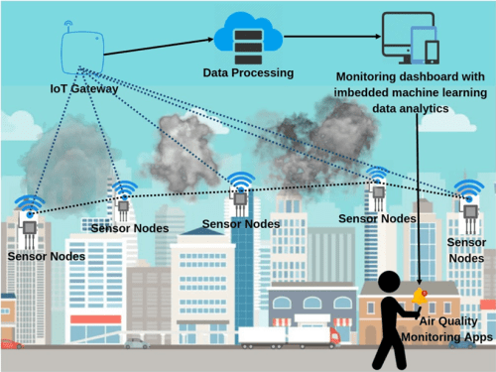](https://www.iotchallengekeysight.com/2019/entries/smart-land/211-0515-025039-real-time-air-quality-monitoring-system-based-on-iot#illustration2-modal)

Air quality sensors are installed in the targeted area on top of buildings, industrial areas, traffic and residential areas. These sensors are connected to a microcontroller to control the sensors network. The data collected by the microcontroller is transmitted to the cloud for analysis. The analyzed data is shared to the public through a smartphone app.

1. How it works

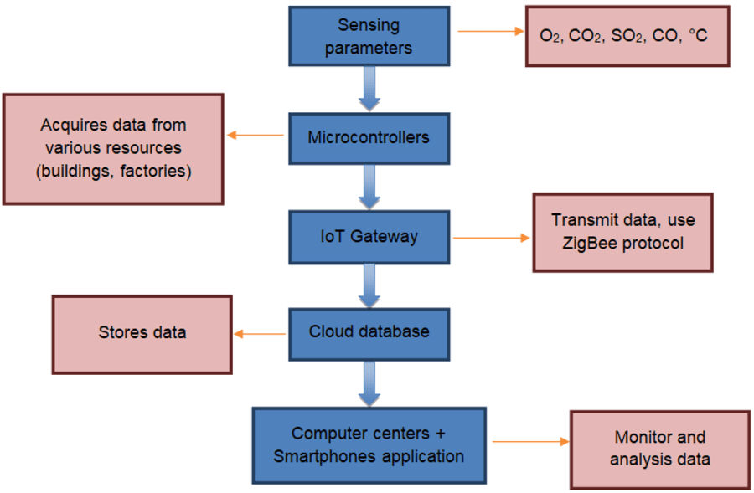

Wireless sensors placed at strategic locations sense the level of dust particles, carbon dioxide, carbon monoxide, nitrogen dioxide and sulfur dioxide in the air. This information is transmitted to a gateway which forwards it to a cloud database by means of cellular or WiFi communication. In the cloud, the data are analyzed to provide information on the air quality. The information on the air quality is shared through a smartphone app. This allows the relevant authority to take remedial action and the community to take precautionary measures.

c) What makes it innovative?  
This project proposes an idea to install monitoring applications on smartphones. It is innovative because it provides easy access to the public to monitor real time air quality in their area. It uses low cost and readily available devices such as a dust sensor, carbon monoxide gas sensor, carbon dioxide gas sensor, and nitrogen dioxide gas sensor. For controlling these sensors, microcontrollers are used and the microcontrollers also act as transmitter to transmit the data to the cloud database. The information on air quality can be accessed through a smartphone app in real time.

d) How would it be produced?  
The IoT based air pollution monitoring system can be produced by using sensors and microcontrollers available in the market. The microcontrollers are programmed to take the sensors as input and transmit the data to the cloud. An algorithm is developed to analyse the data and send it to the smartphones app. Smartphone app will be developed for user to access the air quality information in real-time.

e) Where would it be applied?  
i. Sensors will be installed on top of buildings, industrial areas, traffic and residential areas.  
ii. Smartphone app for monitoring is installed in individual smartphone.

Potential impact around the globe?

There are many cities around the world facing air quality issues. The contaminated air results in death every year and decline in health conditions as people are exposed to unhealthy air quality. Awareness of the contaminated air enables the community to take precautionary steps. This will also enable the relevant authority to take remedial action. With this project the community can enjoy cleaner air and improved health conditions.

[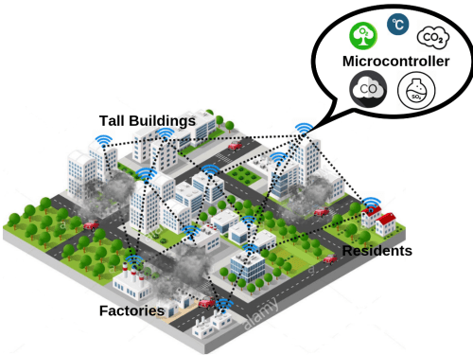](https://www.iotchallengekeysight.com/2019/entries/smart-land/211-0515-025039-real-time-air-quality-monitoring-system-based-on-iot#illustration1-modal)  

**INNOVATIVE IDEAS**

**A.Weather Reporting System using IoT**

One of the best IoT-based projects is the Weather Report system which gives weather forecasts in the surrounding area. This project reduces dependency on weather forecasting agencies. The system collects information from the temperature, humidity, and rain sensors and reports statistics online with the help of the Internet. Red, yellow, and green alerts can be set to identify extreme calamities such as volcanoes, tsunamis, heavy rainfall, and many more.

**B. Flood Detection System using IoT**



Natural calamities like floods cause a lot of damage in many countries almost every year. The flood detection system that predicts floods well in advance is a great project that can also help in preventing huge loss of property life and other valuable assets. The system monitors and detects different environmental factors such as temperature, humidity, or water level for prediction and alert generation to minimize the loss.

* **C.Smart Gas Leakage Detector Bot using IoT**



A gas pipeline is almost like a lifeline of every household and industry sector. Any leakage in it may cause fire, disaster in the factory, or spread toxicity in the air. Chemical students can use their explicit knowledge of chemicals and insert a bot in the pipe to monitor any leak. In case the bot detects any leakage, the location is shared via a GPS sensor over the IoT network.

**D.Home Automation System using IoT**

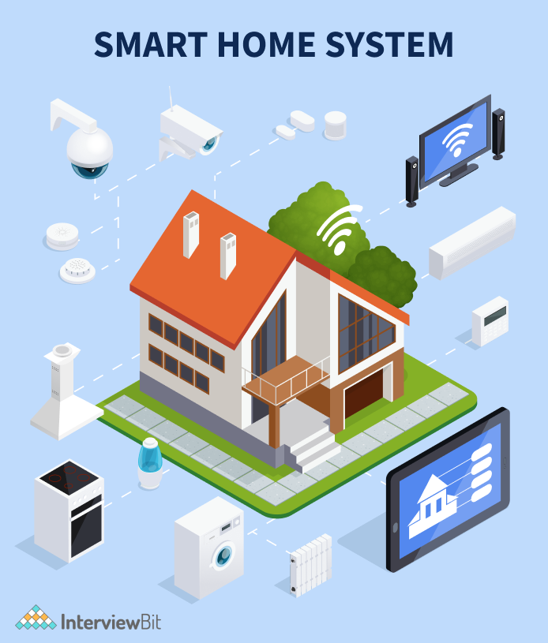

A human touch-based automation system is the most popular IoT project. The system automates all the functions of the appliances in the house such as fans, lights, TV, geyser, and many more which are connected through the IoT network. This project gives you the power to control and manage all the appliances of the house with a single click on the smartphone from any location in the world. An AVR family microcontroller, inbuilt touch-sensing input pins, and a Wi-Fi connection combine the house automation system.

**E. Liquid Level Monitoring System using IoT**

* This Liquid Level Monitoring System monitors multiple liquid levels and prevents them from flooding. Fluids which are used in large volumes in industrial sectors, this system can be of great help in handling them. Not only tracking but also detecting leaks in pipelines can be done with the help of the system. A few sensors that can be used in the monitoring system are Ultrasonic, Conductive, and float sensors.

**F. Smart Garage Door using IoT**



When you are in an extreme hurry and you must waste almost 4-5 minutes to open your garage door manually, drive out of the car and then close the door, how annoying it would be. Smart garage doors using IoT can operate your garage door using the power of the smartphone by integrating with an IoT network. It also eliminates the hassle of locking the door manually. The amazing features of the system can be laser and voice commands along with smart notifications for a better monitoring experience.

**G. Smart Alarm Clock using IoT**



One of the most interesting IoT project ideas is Smart Alarm Clock. It will not only help you in wakening but also works as a functional device loaded with various features. Initiating a chat, voice commands, audio amplifier control, text-to-speech synthesizer, and others are a few of many features.

**H. Smart Parking System using IoT**

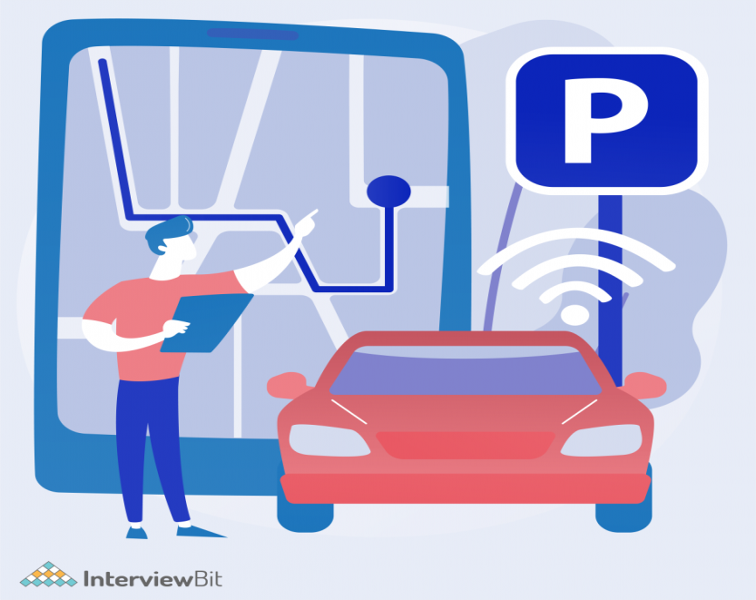

Due to extreme traffic on roads, it is almost impossible to find a vacant parking spot without any hitch. The IoT-based smart Parking System is the solution to tackle all the parking issues. It is designed to avoid parking space hunting for appropriate parking. The system shares the whole picture of the area and gives an image of vacant parking areas so that drivers can ride the car to exact free space.

**13. Smart Traffic Management System using IoT**



As the population is increasing, so is the traffic on roads, IoT based smart traffic management system is the perfect answer to tackle present needs. The system can easily manage all the traffic on roads and offer special pathways in case of emergencies such as fire brigade or ambulances. Also, it is of great help to identify and monitor traffic violators throughout the day and night. Whenever traffic flow needs to be controlled dynamically, this system comes into the picture for emergency vehicles.